**Excerpt from Believing in Horses**

By Valerie Ormond 2012

*Valerie Ormond is a former naval intelligence officer and a freelance writer.* Believing in Horses *tells the story of a young girl who moves to Maryland and gets a new horse, who she develops a close bond with. In this excerpt, Sadie and her horse get caught in a storm. As you read, take notes on what Lucky’s company provides Sadie.*

[1] When no one else showed up at the barn, Sadie rode Lucky in the outdoor arena, schooled him over small jumps, and worked on her equitation[1]skills. She thought back to her first day on Lucky when the big blue heron had swooped down, and realized how far they had come together. Perhaps because there were no other riders in the barn, Sadie felt a tinge of loneliness, and was relieved that she had her best friend, Lucky, right there. After dismounting, Sadie reasoned that it would be safe if she took Lucky for a walk on the trail, leading him instead of riding him. It made sense to her. She had never done it before, but then again she had never thought of it before. She set out on foot and the uneven footing gave her a new appreciation for the abilities of trail horses. After catching a branch or two in the face, she wondered why horses didn’t put up more of a fuss and started paying closer attention to what was ahead of her. Too stubborn to turn around, Sadie forged ahead in the thick mud and tried to enjoy the serenity[2] of the woods.

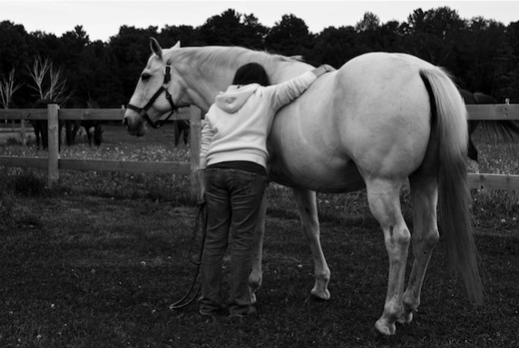

The trail looked quite different on foot than it did atop her big horse. She followed what she thought was the right path and ended up surrounded by holly trees and sticker bushes, clearly in the wrong place. Lucky looked at her as if to say, “I told you it was the other way,” and she couldn’t help but laugh.

“I’ll listen to you at the next fork in the road,” she said, and hugged his neck. They got back on track and descended deeper into the woods; the sounds of deer in the distance were muffled by the leaves rustling as the wind picked up.

[5] Sadie thought she heard a car door shut and found that odd. They were far out in the woods, and she’d never heard anything like that before back here. She chalked it up to her imagination, or a branch breaking, and put her mind back to navigating the roots and rocks on the trail and avoiding the branches that came at her face. Then it began to rain.

It wasn’t a drizzle; it was a downpour. Sadie still hadn’t quite figured out this Maryland weather. It seemed like it could be bright and sunny one minute, pouring rain the next, and then bright and sunny again. It hadn’t been a nice day, but she hadn’t expected this! Sadie couldn’t see two feet in front of her face. A thunder clap came from above, as loud as she’d ever heard, and she thought it shook the earth. Lucky pulled back on the reins, but considering the sound of the thunder, he behaved well.

Sadie stood still and comforted Lucky, at the same time comforting herself. She looked to see if there was any shelter under which they could hide from the storm, but she couldn’t see anything. Then she remembered seeing an old abandoned deer stand on the trail. Sadie was pretty sure it was only a few hundred yards from where they stood and set out to find it, leading the way for Lucky. The sky darkened even more, rain pelted them, and the wind howled. Sadie regretted going out on the trail alone now.

Another clap of thunder shook their ears, and Sadie looked back to ensure Lucky was okay. His eyes were wide, his nostrils flared, but he looked at Sadie as if he trusted her. Sadie continued forward, picking up the pace because she wasn’t sure how long Lucky could keep his cool. Thinking she was on a familiar path, she turned back to Lucky to calm him and tell him they were almost there. By the time she faced forward again, it was too late. She plunged down a deep ravine[3] and into a stream at the bottom with a loud splash and a scream.

Lucky’s instincts to flee from danger took over. Sadie had let the reins go during her fall. Lucky took off in a terrified gallop through the woods.

[10] Sadie could not afford to feel pain or panic. She had to get a hold of herself quickly. She pulled herself out from the mud, climbed up the ravine, and called after Lucky.

It was useless. He was well out of her earshot, and the rain and thunder were too loud. Horses instinctively return to their homes, and Sadie hoped that Lucky was on his way back to the barn. She didn’t blame him for being so scared and losing his confidence in her.

Sadie went for her cell phone to let somebody know what was happening. This was no longer about her stubbornness or pride, it was about making sure Lucky was safe. Of course, her cell phone was safely tucked into her saddle bag — on Lucky. She took a deep breath, told herself that was okay, and that everyone would find out soon enough what was going on when Lucky came galloping up the path to the barn alone. As a source of strength she said out loud, “I believe you’re going to know what to do, Lucky,” and trudged back towards the barn, paying very close attention to where she was going this time.

*Believing in Horses by Valerie Ormond. Copyright © 2012 by Valerie Ormond. Used with permission of author. All rights reserved.*

1. 1. the art and practice of horsemanship and horse riding
2. 2. **Serenity *(noun):*** the state of being calm or peaceful
3. 3. a narrow, steep-sided valley